ROSSMOYNE SENIOR HIGH SCHOOL

Semester Two Examination, 2010

Question/Answer Booklet

MATHEMATICS:
SOLUTIONS

SPECIALIST

3A/3B

Section One:

Calculator-free

Time allowed for this section
Reading time before commencing work: 5 minutes
Working time for paper: 50 minutes

Material required/recommended for this section

To be provided by the supervisor
This Question/Answer booklet
Formula sheet

To be provided by the candidate
Standard items: pens, pencils, pencil sharpener, eraser, correction fluid, ruler, highlighters

Special items: nil

Important note to candidates

No other items may be used in this section of the examination. It is your responsibility to ensure that you do not have any unauthorised notes or other items of a non-personal nature in the examination room. If you have any unauthorised material with you, hand it to the supervisor before reading any further.

Structure of this paper

Section | Number of questions available | Number of questions to be answered | Working time (minutes) | Marks available
Section One:  Calculator-free | 7 | 7 | 50 | 40
Section Two:  Calculator-assumed | 11 | 11 | 100 | 80
 |  |  |  | 120

Instructions to candidates

- The rules for the conduct of Western Australian external examinations are detailed in the Year 12 Information Handbook 2010. Sitting this examination implies that you agree to abide by these rules.

- Write your answers in the spaces provided in this Question/Answer Booklet. Spare pages are included at the end of this booklet. They can be used for planning your responses and/or as additional space if required to continue an answer.
- Planning: If you use the spare pages for planning, indicate this clearly at the top of the page.
- Continuing an answer: If you need to use the space to continue an answer, indicate in the original answer space where the answer is continued, i.e. give the page number. Fill in the number of the question(s) that you are continuing to answer at the top of the page.

- Show all your working clearly. Your working should be in sufficient detail to allow your answers to be checked readily and for marks to be awarded for reasoning. Incorrect answers given without supporting reasoning cannot be allocated any marks. For any question or part question worth more than two marks, valid working or justification is required to receive full marks. If you repeat an answer to any question, ensure that you cancel the answer you do not wish to have marked.

- It is recommended that you do not use pencil except in diagrams.

Section One: Calculator-free (40 Marks)
This section has seven (7) questions. Answer all questions. Write your answers in the space provided.

Working time for this section is 50 minutes.

Question 1 (4 marks)
The functions 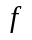 and are defined by 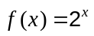 and 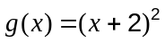.

(a) State the range of . (1 mark)
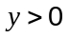 

(b) State the domain of the inverse of . (1 mark)
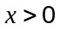 

(c) State the natural domain and range for the composite function 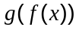. (2 marks)
Domain:
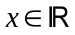 

Range:
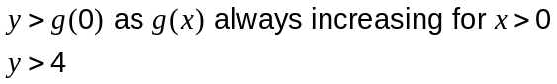


Question 2 (6 marks)
Determine 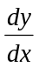 for each of the following

(a) 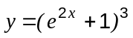 (2 marks)

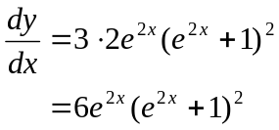

(b) 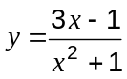 (2 marks)
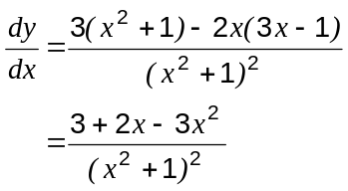

(c) 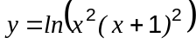 (2 marks)

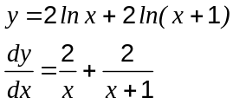
Question 3 (6 marks)
(a) If 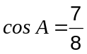 and 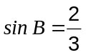 , where A and B are both acute, determine an exact value for 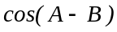. (3 marks)
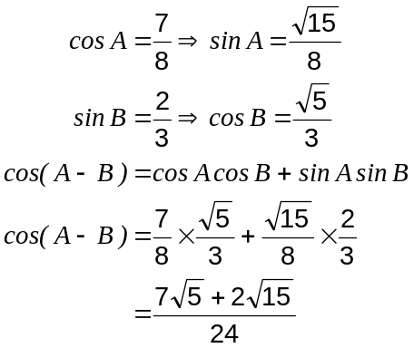

(b) Prove that 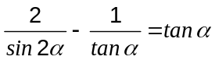. (3 marks)

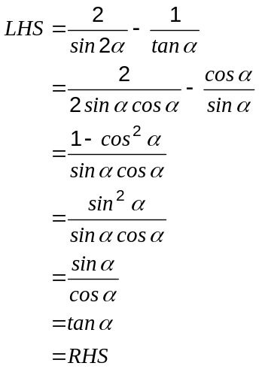
Question 4 (7 marks)
(a) Given that 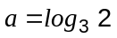 and 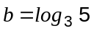, find in terms of and :

(i) 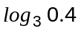 (2 marks)
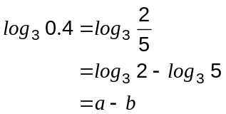

(ii) 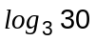 (2 marks)
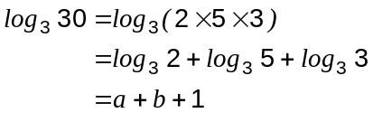

(b) For each of the following, express in terms of .

(i) 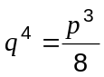 (1 mark)
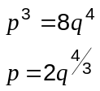

(ii) 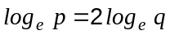 (1 mark)
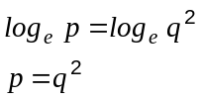

(iii) 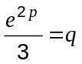 (1 mark)

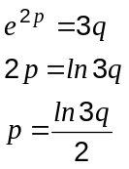
Question 5 (5 marks)
Solve 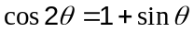, for 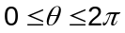.
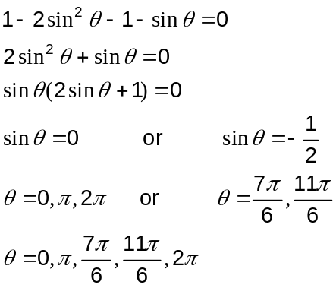

Question 6 (6 marks)
A function is defined by 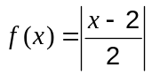.

(a) Draw the graph of  on the axes below. (2 marks)
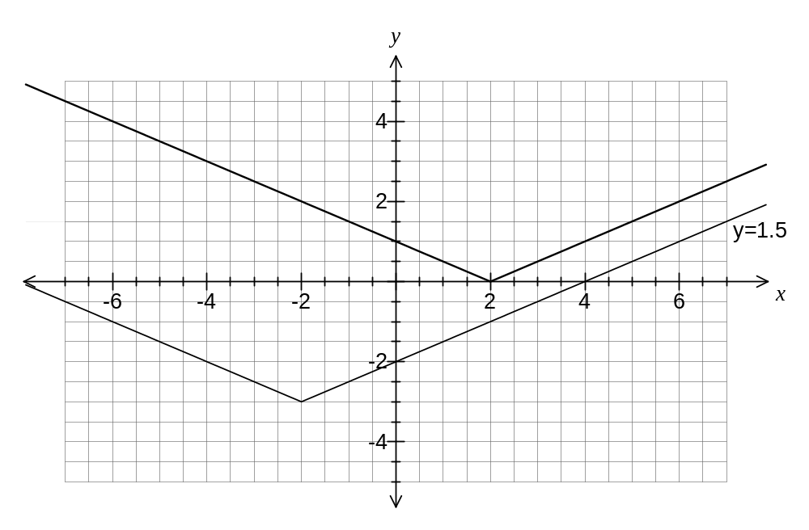

(b) On the same axes, draw the graph of 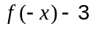. (2 marks)

(c) Using your graph, or otherwise, solve 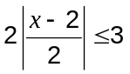. (2 marks)

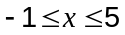

Question 7 (6 marks)
The graphs of the functions are shown below, where 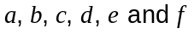 are real constants.
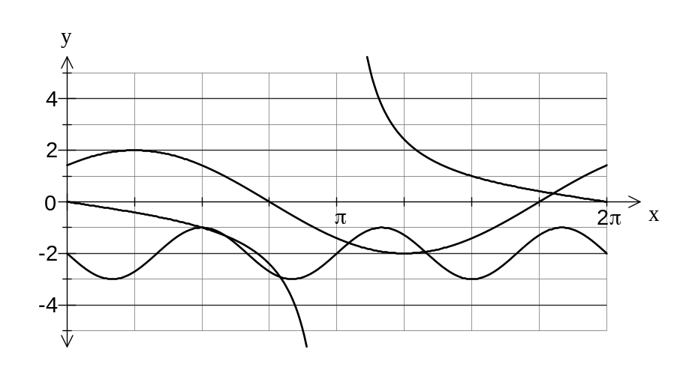

State the values of constants .
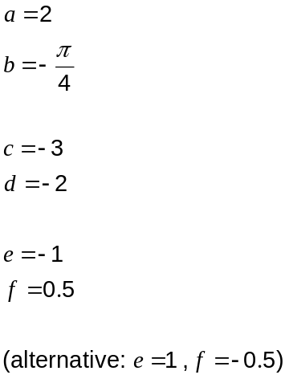

Additional working space

Question number(s):

Additional working space

Question number(s):

